**Crime Data Analysis Report Tamil Nadu**

**(2014‑ Present)**

# 1. Introduction

Understanding crime patterns over time is fundamental to evidence‑based policing and public‑safety policy. Tamil Nadu, one of India’s most urbanised states, exhibits a dynamic mix of traditional offences (property, violent) and emerging digital threats (cyber‑crime). This report dissects nine years of official crime data to uncover trends, diagnose underlying drivers, and recommend practical interventions.

# 2. Objectives & Scope

The study was commissioned by Albaatros with four primary objectives:

* Quantify and visualise longitudinal crime trends from 2014 through 2022.
* Identify shifts in crime composition and growth hot‑spots.
* Correlate categories to detect co‑moving offence clusters.
* Translate findings into actionable safety measures for state and district authorities.

# 3. Data Source & Preparation

Data originate from the consolidated “Crime report.xlsx” workbook supplied by the hiring team. Sheet 2 contains 56 specific IPC/SLL offence rows mapped to seven aggregated categories and nine yearly columns (2014‑2022). Key preparation steps included:

* Forward‑filling missing ‘Category’ labels.
* Converting year columns to integers and ensuring numeric types.
* Aggregating specific offences to build category‑level matrices for multi‑year analysis.

No outlier suppression or scaling was applied; counts reflect officially recorded FIRs.

**3.1 Data Preview**

|  |  |  |  |
| --- | --- | --- | --- |
| Specific Crime Type | Category | 2014 | 2022 |
| Murder | Violent Crimes | 103 | 1676 |
| Rape | Violent Crimes | 923 | 1375 |
| Assault / Grievous Hurt | Violent Crimes | 12440 | 9492 |
| Total Violent Crimes | Violent Crimes | 13466 | 12543 |
| Murder for Gain | Property Crimes | 127 | 57 |
| Dacoity | Property Crimes | 101 | 86 |

# 4. Exploratory Analysis & Key Patterns

A battery of statistical charts was produced to surface both macro‑level and micro‑level insights. Each subsection summarises the transformation pipeline, the insight, and its operational implication.

## 4.1 Multi‑Line Trend (Category Totals)

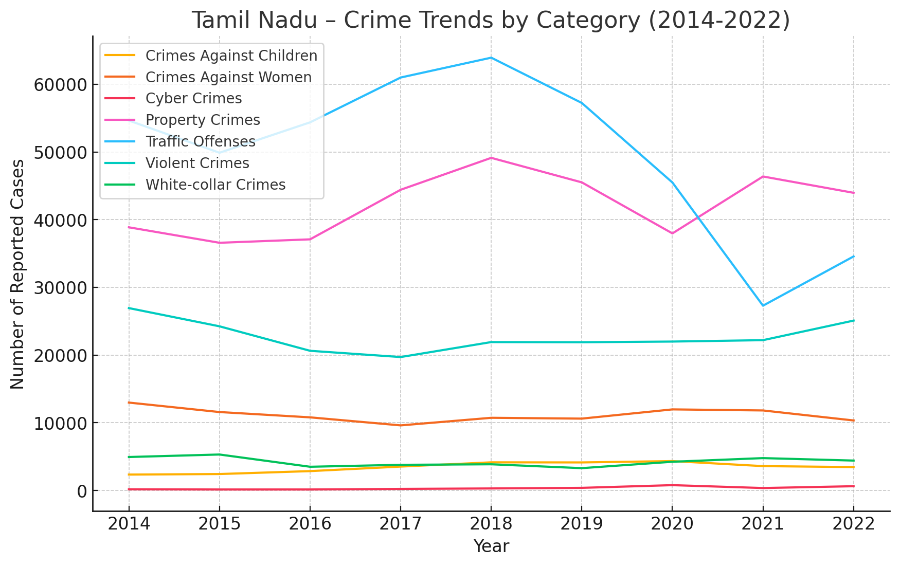

**Input:** Category‑year matrix (7×9). Transformation: summed counts plotted yearly per category.

**Insight:** Cyber and Property crimes rise sharply till 2018; COVID restrictions cause 2020‑21 troughs, followed by partial 2022 rebound. Violent crime remains broadly flat, signalling policing stability in that domain.

## 4.2 Stacked‑Area Composition

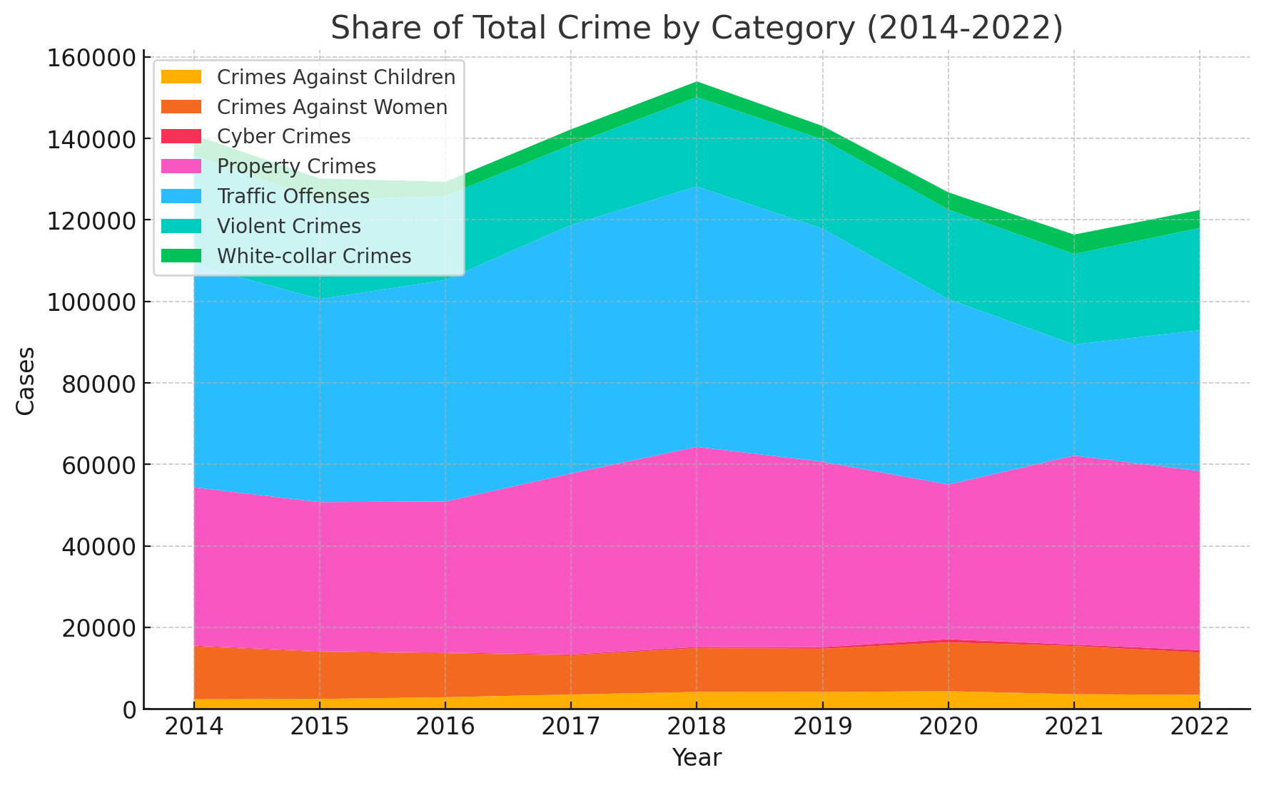

**Input:** same matrix. Transformation: cumulative stackplot to visualise proportional share. **Insight:** Digital and child‑related crimes steadily claim a larger slice of the crime pie, while traffic violations’ share contracts post‑pandemic.

## 4.3 Bar Chart – 2022 Crime Mix

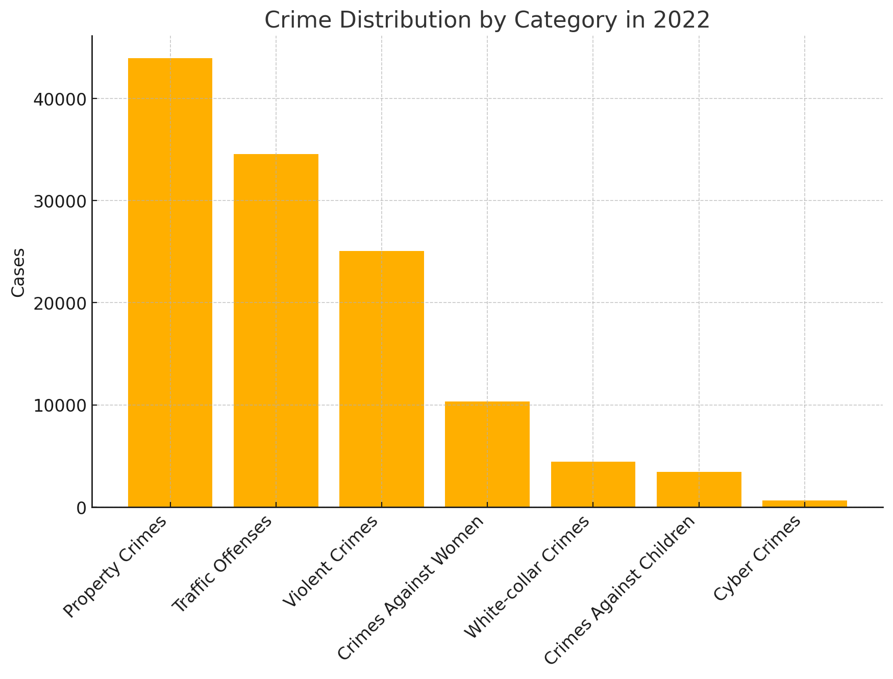

**Input:** 2022 single‑year slice. Transformation: vertical bar ranking categories.

**Insight:** Property and Traffic offences constitute >65 % of all recorded cases, defining frontline workload.

## 4.4 Waterfall – Year‑on‑Year Delta (2021→2022)

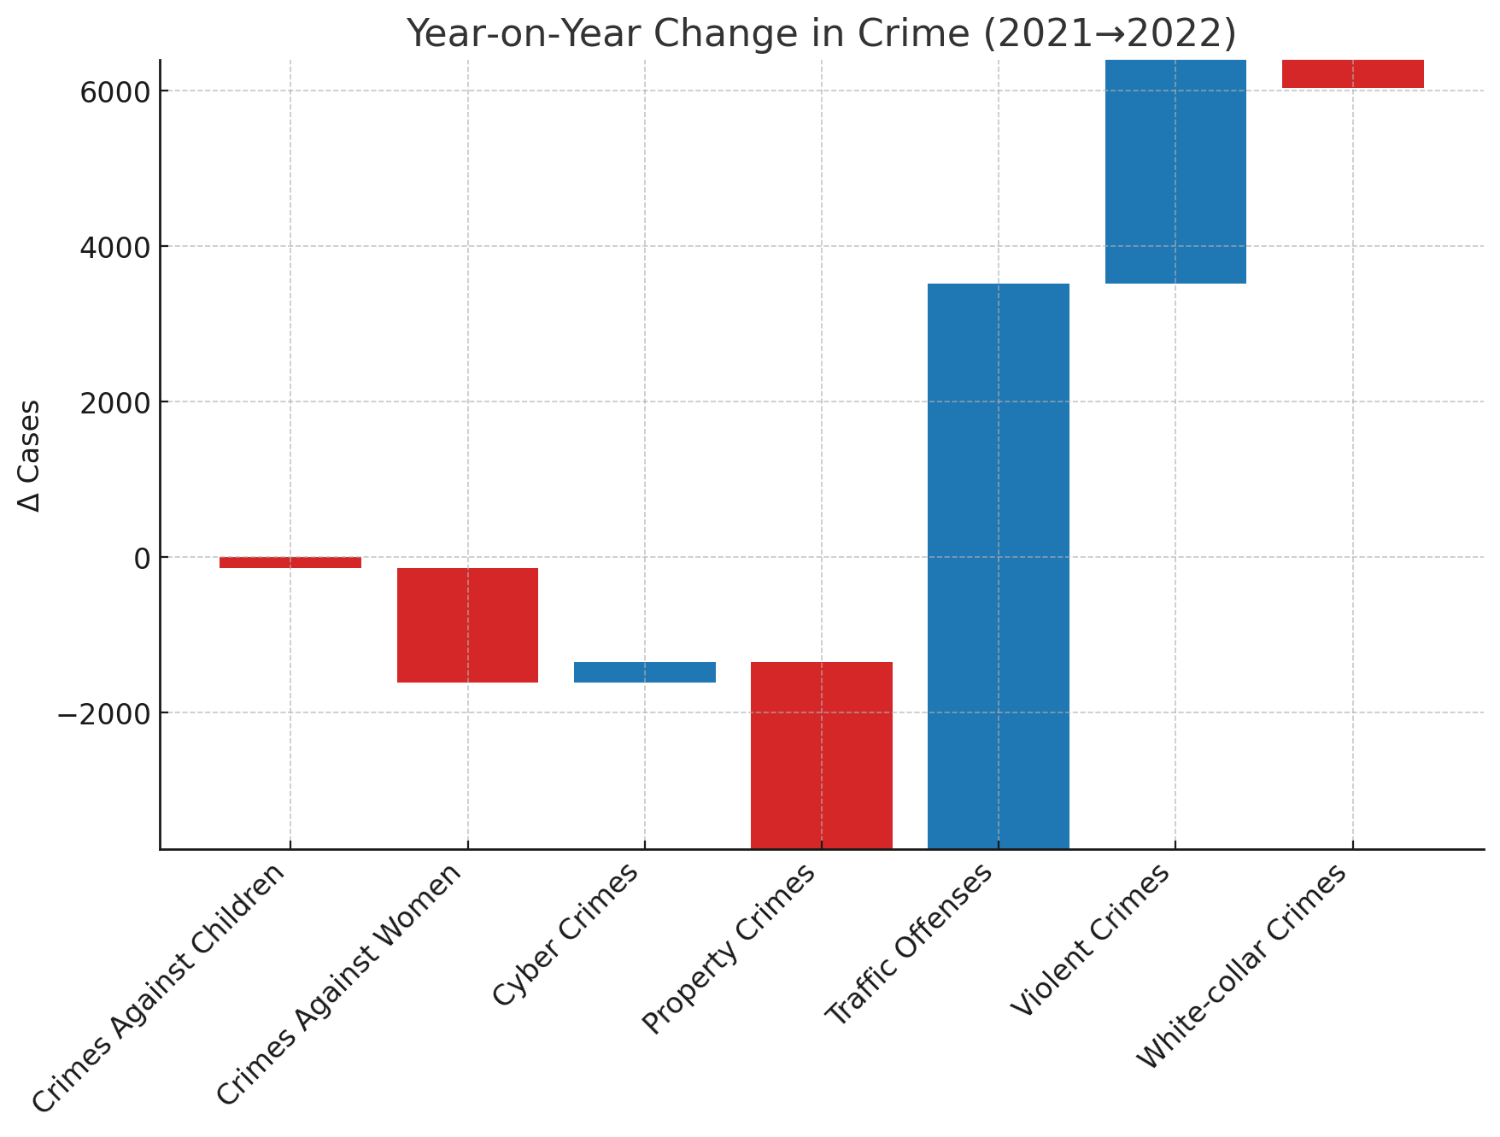

**Input:** Delta vector of 2022 minus 2021 counts. Transformation: sequential waterfall visual.

**Insight:** Traffic offences (+14 k) and Violent crimes (+6 k) account for the bulk of the net statewide increase, pinpointing urgent areas for resource infusion.

## 4.5 Heatmap – Top 15 Specific Offences

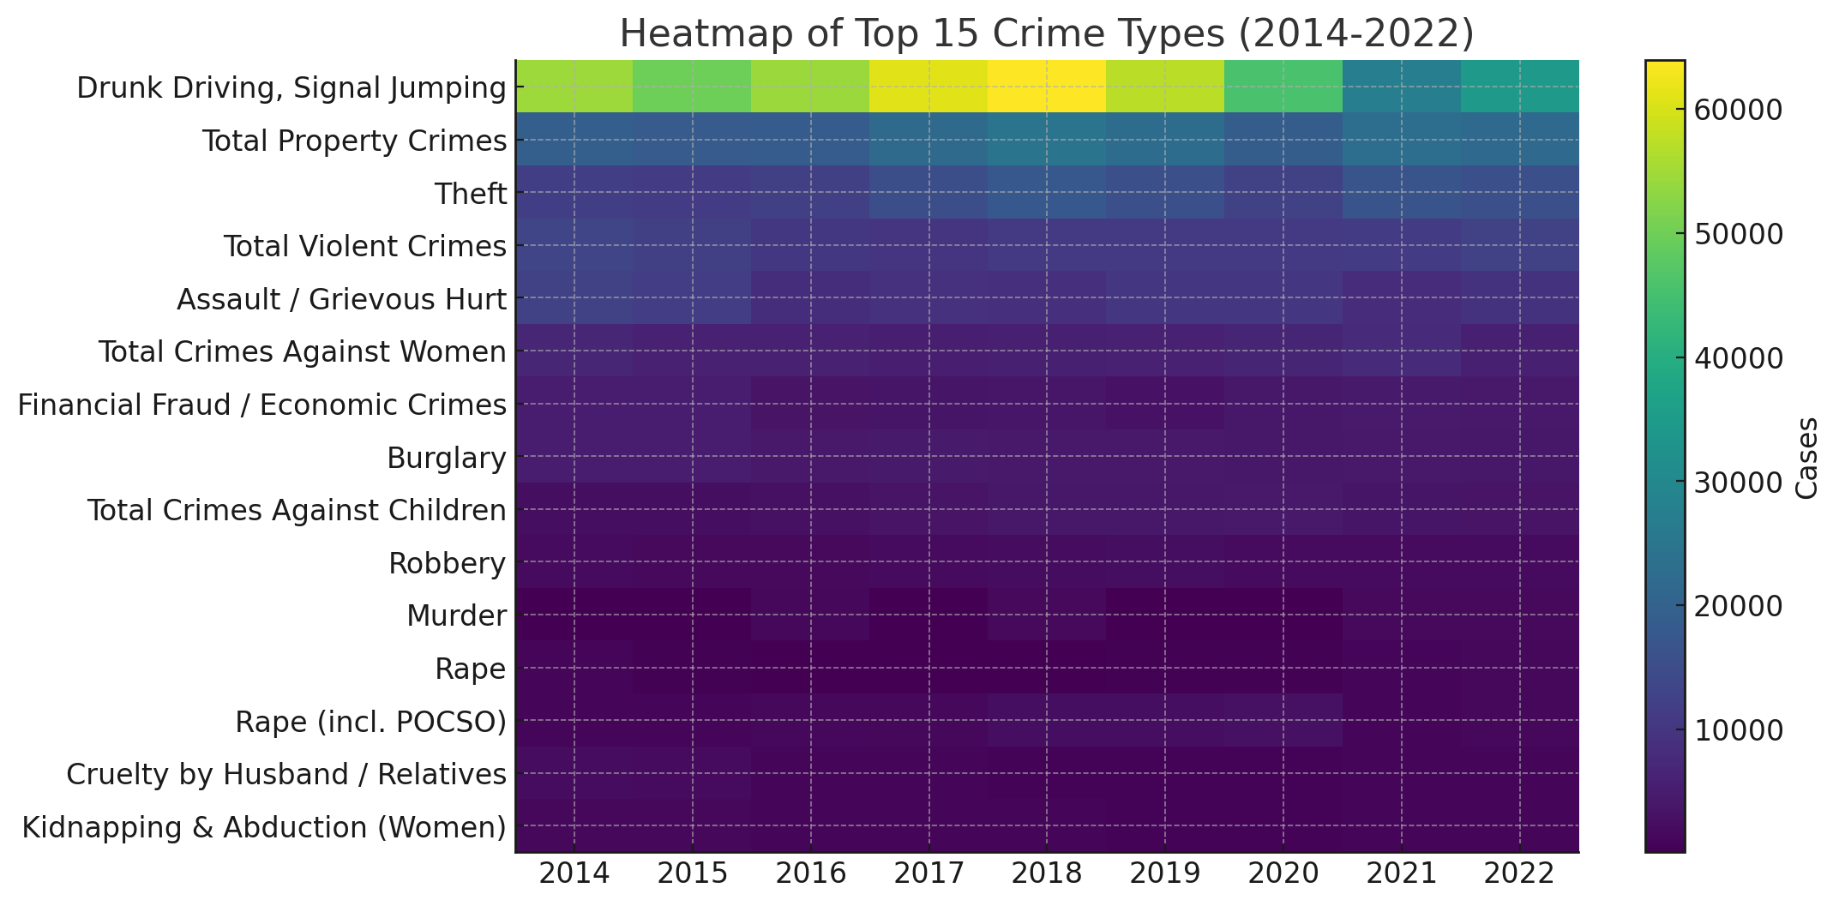

**Input:** top‑15 offences by 2022 volume. Transformation: 15×9 matrix mapped to colour scale.

**Insight:** Drunk Driving dominates throughout; Assault & Theft persistently high; Economic Fraud intensifies 2020‑22, underscoring new financial‑crime vectors.

## 4.6 Percent Change 2014 to 2022

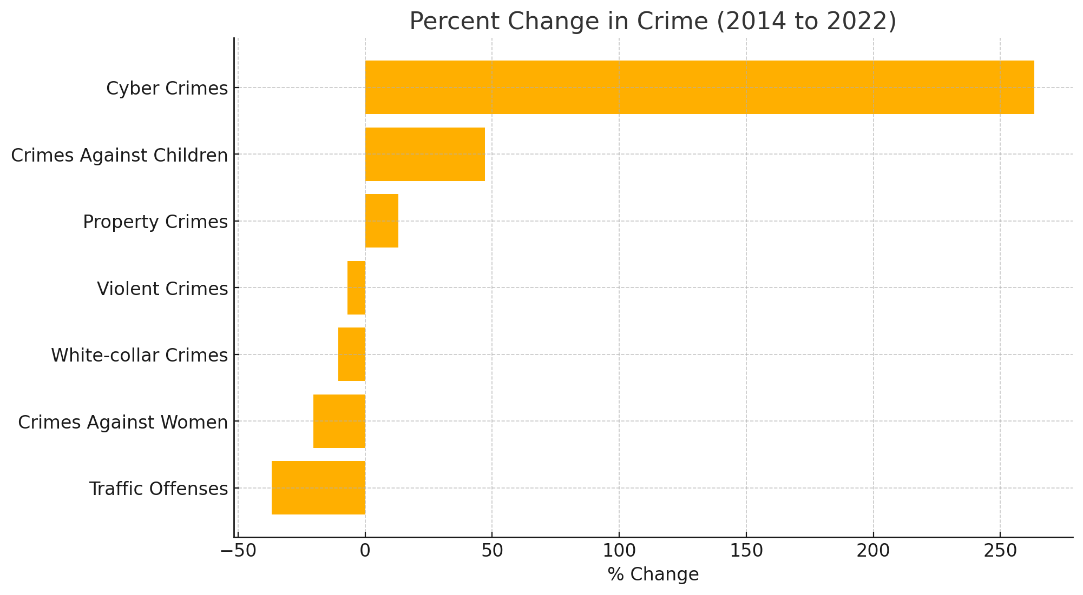

**Input:** base‑year 2014 vs. 2022 counts. Transformation: horizontal bar of % change.

**Insight:** Cyber crime skyrockets (+263 %), Traffic drops (−37 %), validating divergent enforcement success and new threat growth.

## 4.7 Correlation Matrix

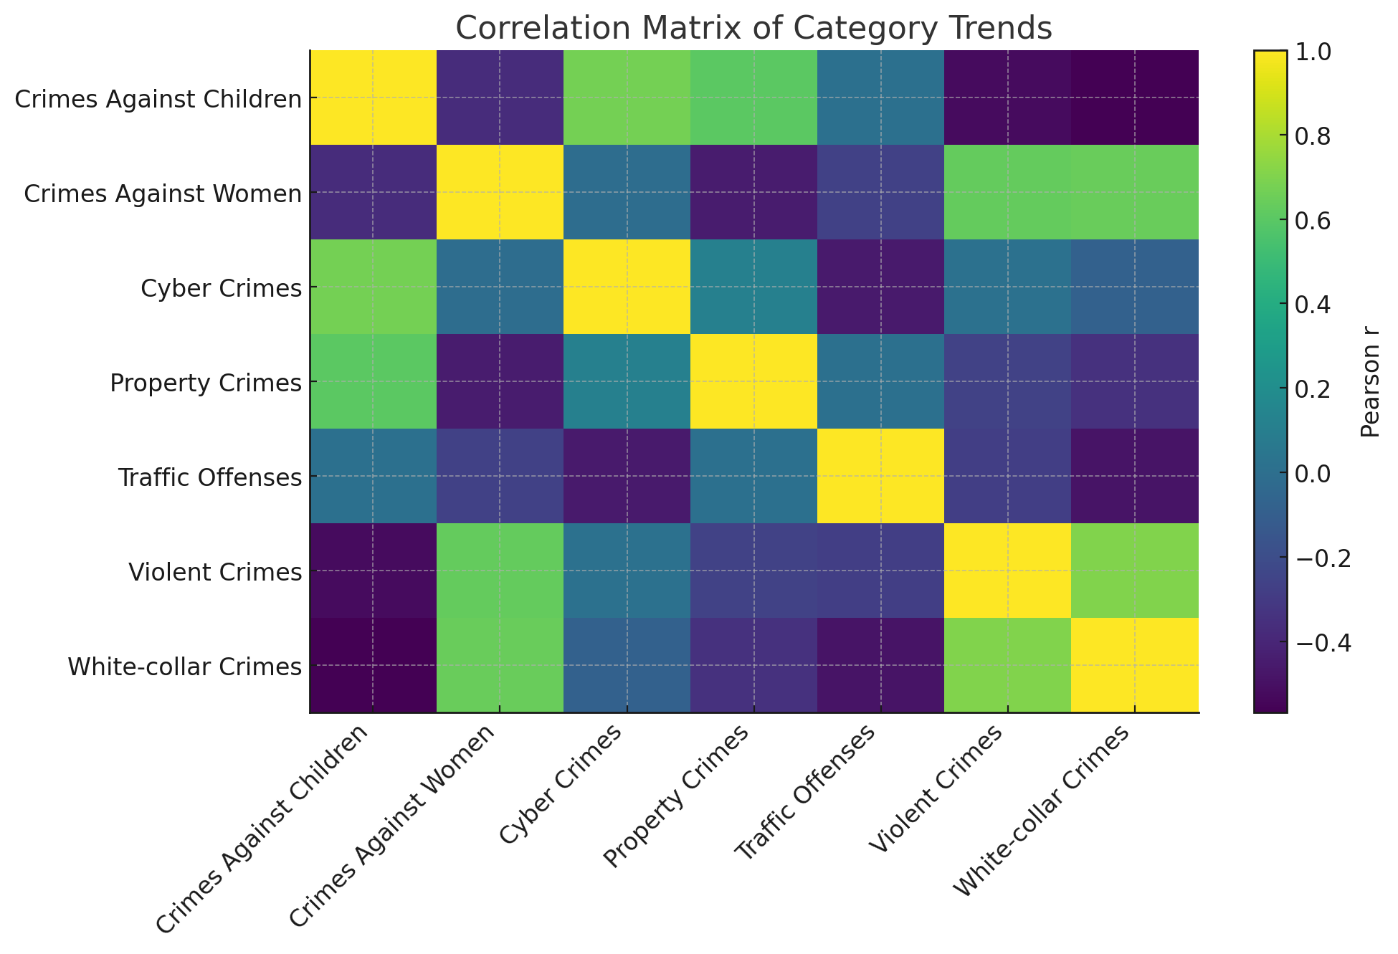

**Input:** Pearson correlations of category trends. Transformation: 7×7 heatmap.

**Insight:** Violent & White‑collar crimes correlate (r≈0.66) hinting at socio‑economic stress overlap; Cyber vs. Traffic mildly inverse (r≈‑0.35), likely influenced by movement restrictions.

## 4.8 3‑Year CAGR (2019‑22)

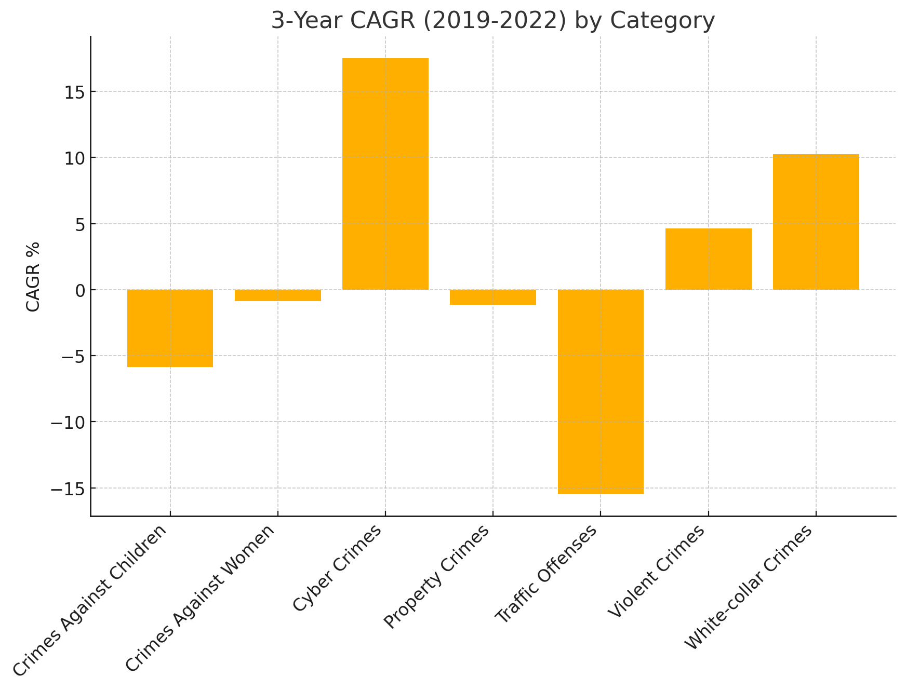

**Input:** 2019 and 2022 counts. Transformation: compound annual growth computation.

**Insight:** Cyber crime exhibits +17 % CAGR, fastest among all categories, signalling sustained momentum even post‑lockdown.

## 4.9 Pareto Chart – Top 20 Offences 2022

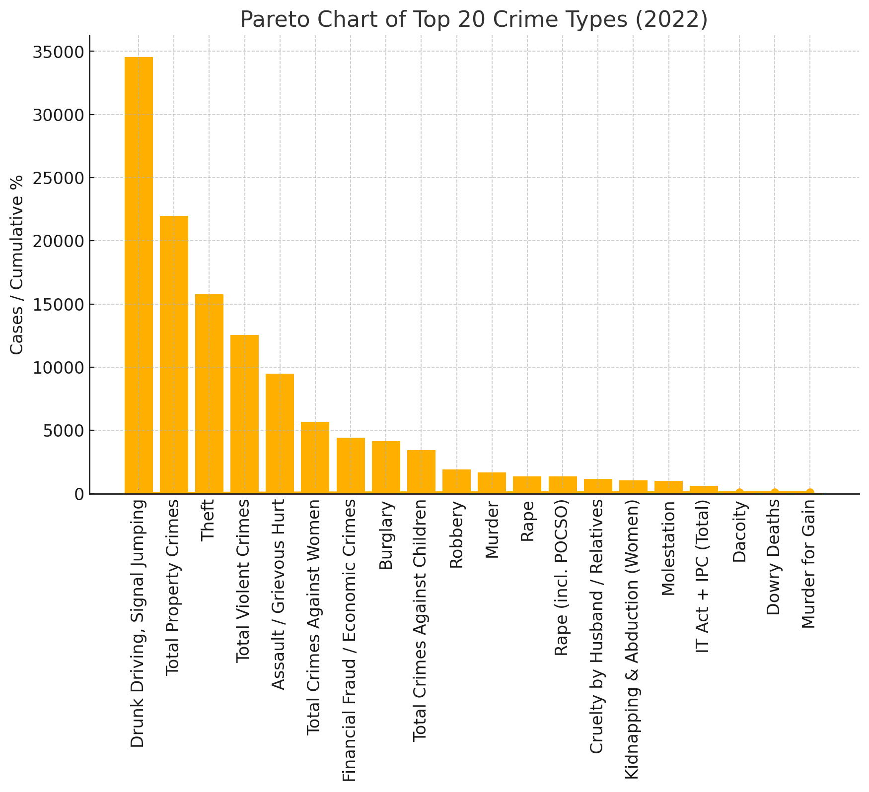

**Input:** 2022 offence counts sorted. Transformation: bar + cumulative percentage line.

**Insight:** First three offences comprise >50 % of total volume, suggesting concentrated enforcement could yield outsized impact.

# 5. Insights & Discussion

The analytical suite converges on three narrative arcs:

* **Digital Surge:** Cyber‑crime and economic fraud are exponential, demanding specialised cyber forensics and public literacy campaigns.
* **Pandemic Distortion:** 2020‑21 saw artificial dips in mobility‑linked crimes; 2022 rebound proves suppressed, not solved, problems.
* **Concentrated Offences:** A minority of offence types—chiefly traffic violations, petty theft, and assault—consume the majority of policing effort.

# 6. Recommendations & Safety Measures

**6.1 Cyber‑crime Mitigation**

* Establish district‑level cyber desks with trained digital volunteers.
* Run quarterly phishing‑awareness drives for SMEs and college campuses.

**6.2 Traffic Offence Control**

* Expand AI‑enabled speed cameras to tier‑2 highways.
* Implement ‘No Helmet, No Fuel’ statewide.
* Integrate e‑challan collection with vehicle‑fitness renewals.

**6.3 Property & Violent Crime**

* Hotspot policing informed by theft density heat‑maps.
* Community mediation centres to pre‑empt assault escalations.
* Subsidised CCTV schemes for small businesses.

**6.4 Children & Women Safety**

* Deploy school cyber‑tipline interface.
* Strengthen One‑Stop Crisis Centres co‑located with district hospitals.

# 7. Conclusion

Tamil Nadu’s crime landscape is at an inflection point. Traditional offences remain substantial, but digital and economic crimes are the fastest‑growing threats. Data‑driven resource allocation—prioritising cyber capacity, traffic enforcement tech, and targeted property‑crime patrols—can yield the greatest marginal safety return. Continuous year‑on‑year monitoring is recommended to evaluate the effectiveness of proposed interventions.